Tatton Wildlife Newsletter – Autumn

Autumn is a fantastic month to enjoy being out in the parkland. With the deer rut in full swing, migratory birds on the move and fungi plentiful, the ‘season of mists and mellow fruitfulness’ is a magical time to explore and witness the seasonal changes it brings.

Deer

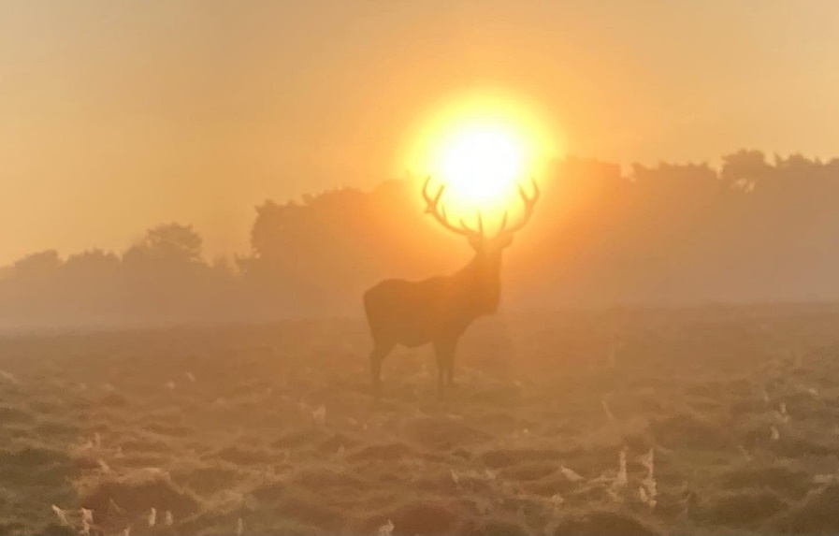 This is the season when the deer are rutting. The males will begin to wallow in watery scrapes, covering themselves in mud, adorning their antlers with grass, in the hope of making themselves look more intimidating. They become more vocal; the red deer bellowing and the fallow delivering a belching, rasping call. All this behaviour is to compete with other males and to mate with the females.

The last resort is the actual fighting when they will lock antlers in a physical battle of strength. The victor will be the strongest animal, making sure his genes are inherited back into the herd. Injuries do occur but are thankfully uncommon.

The best red stags can have over thirty hinds in a harem. He will move around with the group, keeping rival males away and herding his females together. The fallow bucks hold a territory called a ‘stand’ where he will attract females into his territory to mate with them.

Please keep your distance from the deer as they can act aggressively.

Birds

Autumn is a fantastic season for birdwatchers as winter birds arrive and our summer visitors depart. Birds are passing through on migration and rarer species can now be seen. Waders occasionally drop in on the mere margins and a late osprey or hobby may be seen before they head to Africa.

Redwings and fieldfares, winter thrushes from Scandinavia, will arrive here frantically feeding up on berries. Wildfowl numbers increase, as they too arrive from the north.

Stonechats bred here again over the summer, and it was rewarding to see three fledglings on the banks of Melchett Mere. Ravens also had a good year as did our herons at Higmere.

Hazel Coppicing and Dead Wood Hedging

The hazel stands in Millenium Wood are managed as a small coppice with a rotation of 5 /6 years. Coppicing is a method of woodland management which involves cutting broadleaved trees down to the ground at regular intervals. New shoots sprout up from the stump and these eventually provide new, manageable straight poles.

Many of these poles are used as stakes for dead wood hedges throughout the estate, most noticeable in Dairy Wood Way. These hedges provide a natural aesthetic barrier to help define the paths while providing excellent habitat.

Fungi

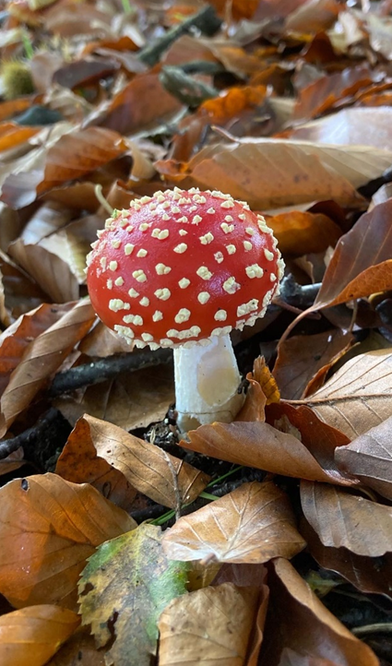 Fungi are synonymous with autumn and many species can be seen at Tatton. Colourful species such as the iconic fly agaric (pictured opposite), amethyst deceiver and waxcaps are found here along with hundreds of others. Each year we deliver a ‘fungal foray’, and we have on occasion recorded over a hundred species in four hours! These fungi provide an essential job by breaking down decaying matter and are the building blocks of our ecosystems.

We advise against foraging, believing it better to leave them to do their job and let others enjoy their beautiful spectacle.

***Compiled by Tatton’s Ranger Team***